（单位：mm）

本体

引线式
SN08-单倍距离
SN08-1B5NA,SN08-1B5NB,SN08-1B5PA,SN08-1B5PB
SN08-02DNA,SN08-02DNB,SN08-02DPA,SN08-02DPB
SN08-两倍距离
SN08-02BNA,SN08-02BNB,SN08-02BPA,SN08-02BPB
SN08-04DNA,SN08-04DNB,SN08-04DPA,SN08-04DPB
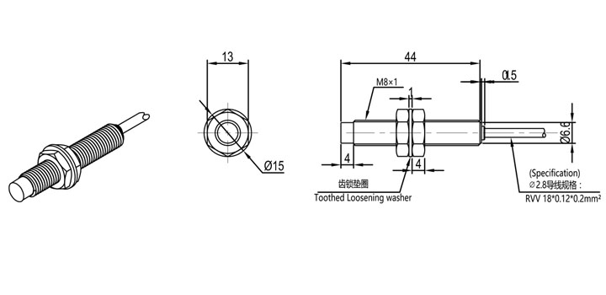
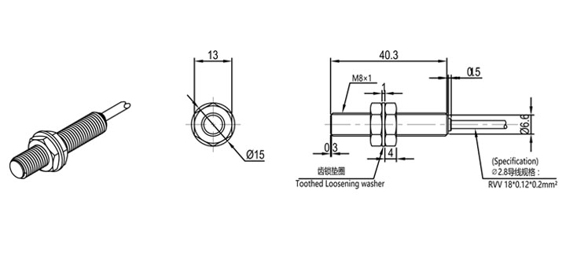
SN12-单倍距离
SN12-02BNA,SN12-02BNB,SN12-02BPA,SN12-02BPB
SN12-04DNA,SN12-04DNB,SN12-04DPA,SN12-04DPB
SN12-两倍距离
SN12-04BNA,SN12-04BNB,SN12-04BPA,SN12-04BPB
SN12-08DNA,SN12-08DNB,SN12-08DPA,SN12-08DPB
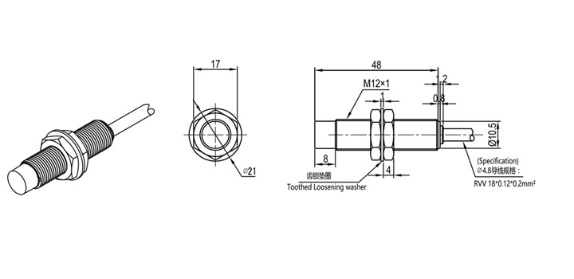

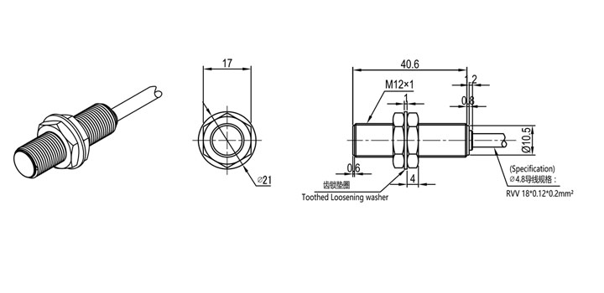
SN18-单倍距离
SN18-05BNA,SN18-05BNB,SN18-05BPA,SN18-05BPB
SN18-08DNA,SN18-08DNB,SN18-08DPA,SN18-08DPB
SN18-两倍距离
SN18-08BNA,SN18-08BNB,SN18-08BPA,SN18-08BPB
SN18-12DNA,SN18-12DNB,SN18-12DPA,SN18-12DPB
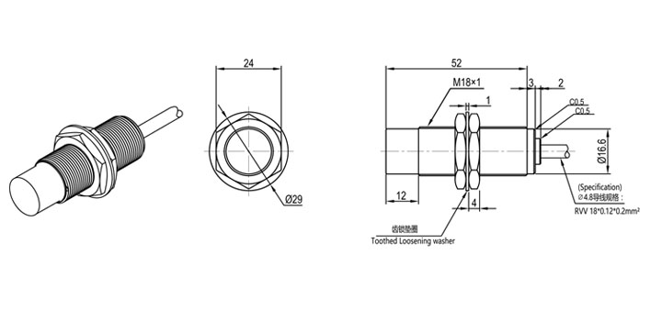
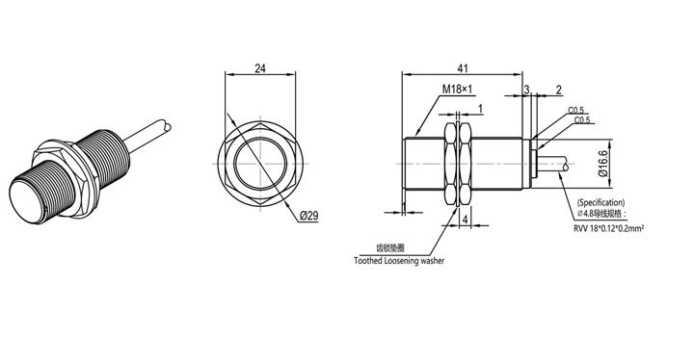
SN30-单倍距离
SN30-10BNA,SN30-10BNB,SN30-10BPA,SN30-10BPB
SN30-15DNA,SN30-15DNB,SN30-15DPA,SN30-15DPB
SN30-两倍距离
SN30-15BNA,SN30-15BNB,SN30-15BPA,SN30-15BPB
SN30-22DNA,SN30-22DNB,SN30-22DPA,SN30-22DPB
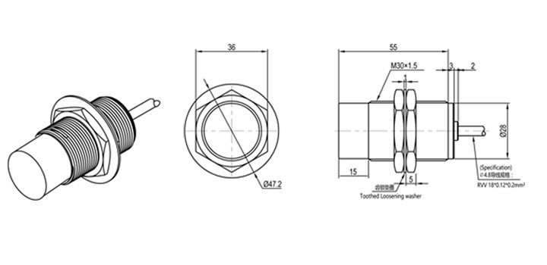

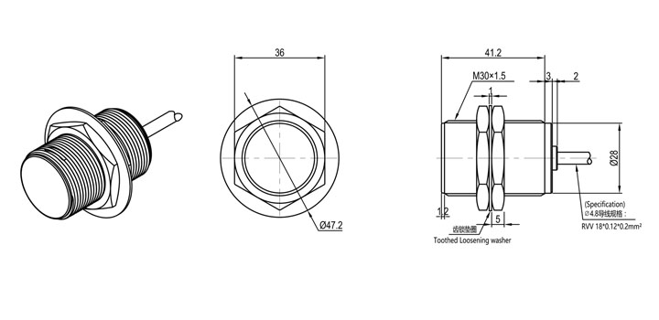
插件式
SN08-E 单倍距离
SN08-1B5NA-E,SN08-1B5NB-E,SN08-1B5PA-E,SN08-1B5PB-E
SN08-02DNA-E,SN08-02DNB-E,SN08-02DPA-E,SN08-02DPB-E
SN08-E 两倍距离
SN08-02BNA-E,SN08-02BNB-E,SN08-02BPA-E,SN08-02BPB-E
SN08-04DNA-E,SN08-04DNB-E,SN08-04DPA-E,SN08-04DPB-E
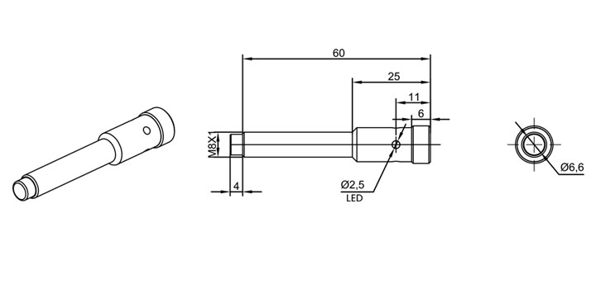
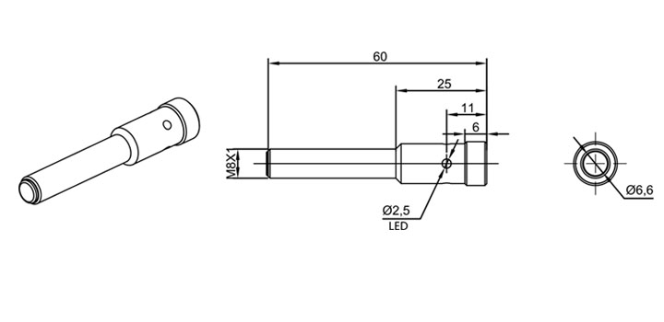
SN12-E 单倍距离
SN12-02BNA-E,SN12-02BNB-E,SN12-02BPA-E,SN12-02BPB-E
SN12-04DNA-E,SN12-04DNB-E,SN12-04DPA-E,SN12-04DPB-E
SN12-E 两倍距离
SN12-04BNA-E,SN12-04BNB-E,SN12-04BPA-E,SN12-04BPB-E
SN12-08DNA-E,SN12-08DNB-E,SN12-08DPA-E,SN12-08DPB-E
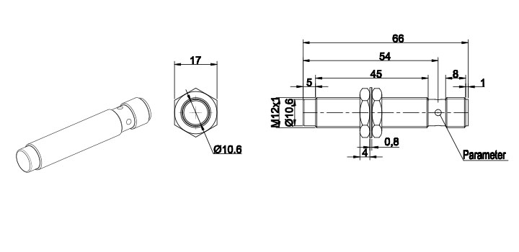
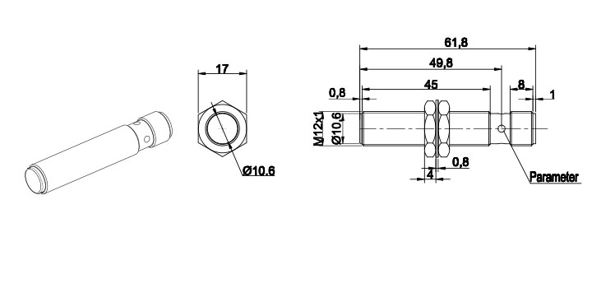
SN18-E 单倍距离
SN18-05BNA-E,SN18-05BNB-E,SN18-05BPA-E,SN18-05BPB-E
SN18-08DNA-E,SN18-08DNB-E,SN18-08DPA-E,SN18-08DPB-E
SN18-E 两倍距离
SN18-08BNA-E,SN18-08BNB-E,SN18-08BPA-E,SN18-08BPB-E
SN18-12DNA-E,SN18-12DNB-E,SN18-12DPA-E,SN18-12DPB-E
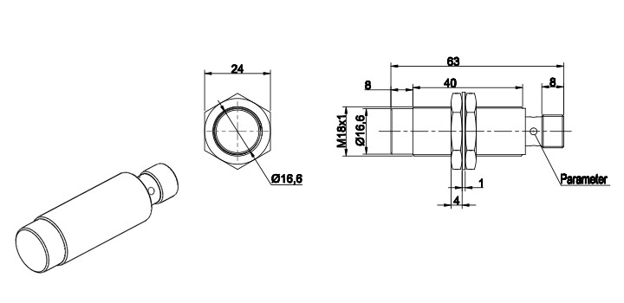
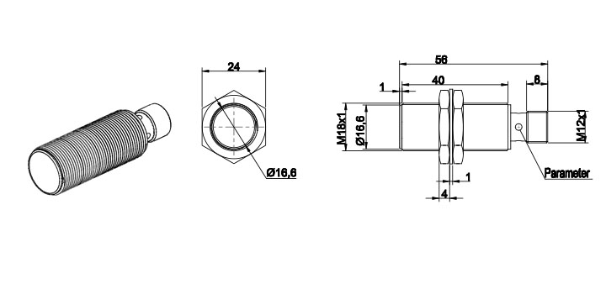
SN30-E 单倍距离
SN30-10BNA-E,SN30-10BNB-E,SN30-10BPA-E,SN30-10BPB-E
SN30-15DNA-E,SN30-15DNB-E,SN30-15DPA-E,SN30-15DPB-E
SN30-E 两倍距离
SN30-15BNA-E,SN30-15BNB-E,SN30-15BPA-E,SN30-15BPB-E
SN30-22DNA-E,SN30-22DNB-E,SN30-22DPA-E,SN30-22DPB-E
