（单位：mm）

本体

M12-3FVL-02

M12-4FVL-02
M12-5FVL-02
M12-8FVL-02
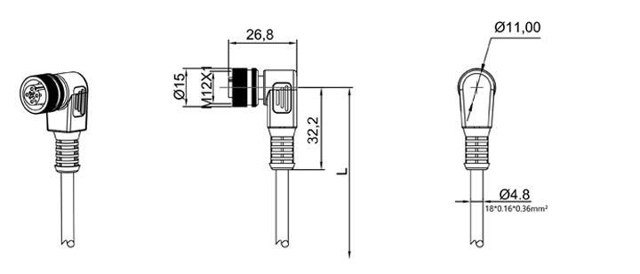

M12-3FVR-02
M12-4FVR-02
M12-5FVR-02
M12-8FVR-02

