单位：mm）

本体

引线式
M12-11FV-02YP, M12-11FV-02P
M12-11FV-02YN, M12-11FV-02N
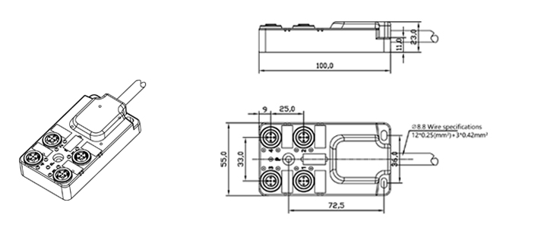

M12-15FV-02YP, M12-15FV-02P
M12-15FV-02YN, M12-15FV-02N

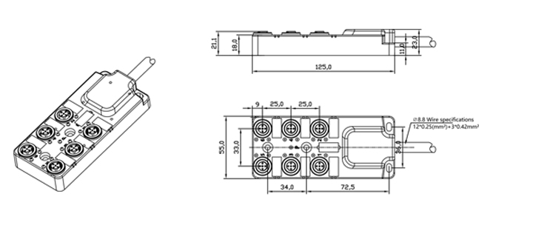

M12-19FV-02YP, M12-19FV-02P
M12-19FV-02YN, M12-19FV-02N

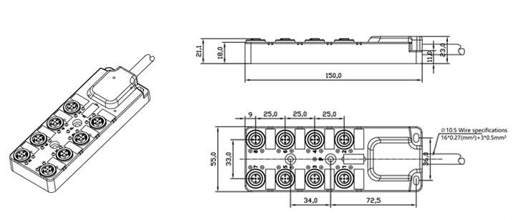

插件式

M12L-11FV-YP, M12L-11FV-P
M12L-11FV-YN, M12L-11FV-N

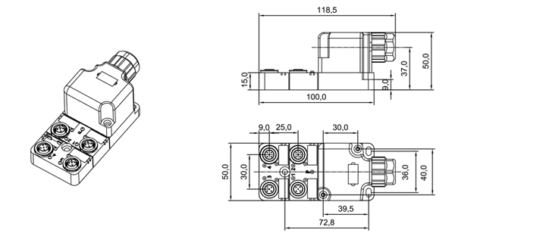

M12L-15FV-YP, M12L-15FV-02P
M12L-15FV-YN, M12L-15FV-02N

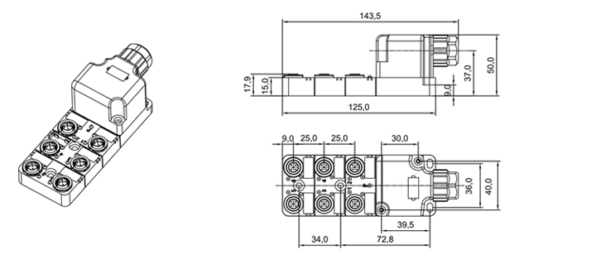

M12L-19FV-YP, M12L-19FV-P
M12L-19FV-YN, M12L-19FV-N

