（单位：mm）

本体

导线引出型

CN12P-02BNA, CN12P-02BNB
CN12P-02BPA, CN12P-02BPB
CN12P-04DNA, CN12P-04DNB
CN12P-04DPA, CN12P-04DPB

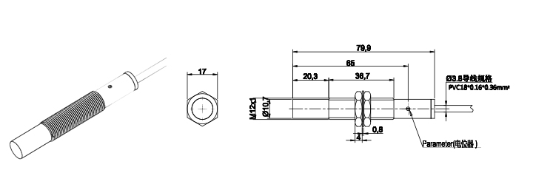

CN18P-05BNA, CN18P-05BNB
CN18P-05BPA, CN18P-05BPB
CN18P-08DNA, CN18P-08DNB
CN18P-08DPA, CN18P-08DPB
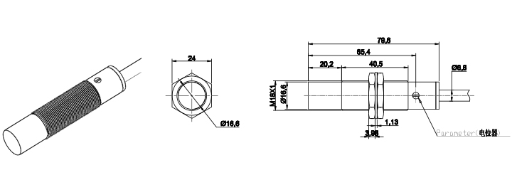

CN30P-10BNA, CN30P-10BNB
CN30P-10BPA, CN30P-10BPB
CN30P-15DNA, CN30P-15DNB
CN30P-15DPA, CN30P-15DPB

