单位：mm）

本体

屏蔽型

SNX12-02BNA , SNX12-02BNB
SNX12-02BPA , SNX12-02BPB
非屏蔽型
SNX12-04DNA , SNX12-04DNB
SNX12-04DPA , SNX12-04DPB
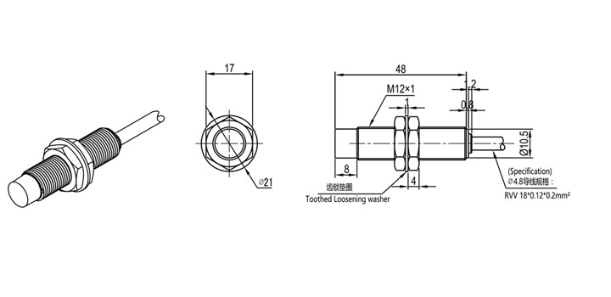
屏蔽型
SNX18-05BNA , SNX18-05BNB
SNX18-05BPA , SNX18-05BPB
非屏蔽型
SNX18-08DNA , SNX18-08DNB
SNX18-08DPA , SNX18-08DPB

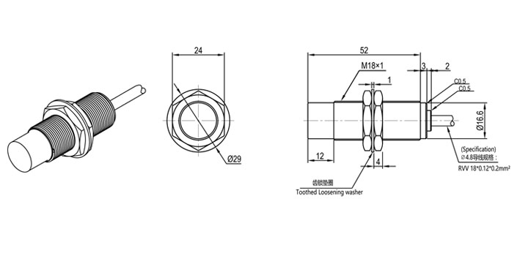

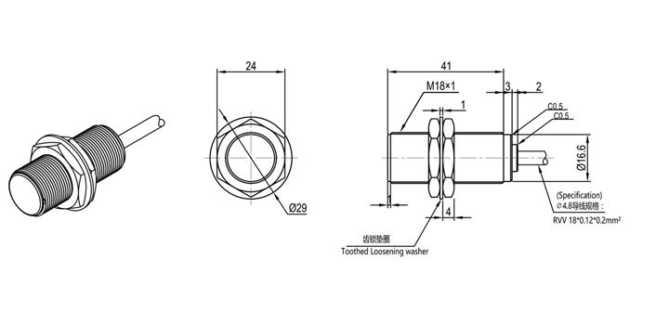
屏蔽型
SNX30-10BNA , SNX30-10BNB
SNX30-10BPA , SNX30-10BPB
非屏蔽型
SNX30-15DNA , SNX30-15DNB
SNX30-15DPA , SNX30-15DPB
