（单位：mm）

本体

SNB12
SNB12-1B5NA-E,SNB12-1B5NB-E,
SNB12-1B5PA-E,SNB12-1B5PB-E,
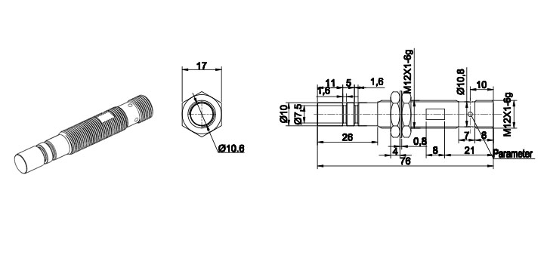
SNB14
SNB14-03BNA-E,SNB14-03BNB-E,
SNB14-03BPA-E,SNB14-03BPB-E,
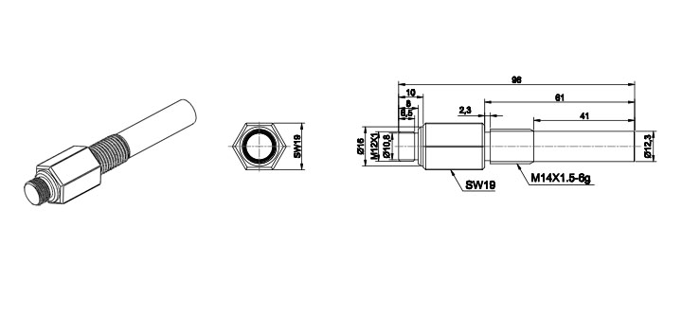

SNB18
SNB18-03BNA-E,SNB18-03BNB-E,
SNB18-03BPA-E,SNB18-03BPB-E,
